O’NEILL, EUGENE (1888-1953)

Eugene O’Neill has been seen as the quintessential modernist among American playwrights, and many of his works show an affinity with the themes and methods of notable modernists, but he resisted alliance with any artistic movement and ultimately resisted involvement in the theatre itself. In his fervent exploration of the means of art, he constantly seemed to be rejecting the methods and even the goals of his contemporaries. Some might call his approach eclectic or experimental, but once his career was finished, it became clear that his experiments were driven by a lifelong project of self-analysis and a frustrated Romantic quest for fulfillment.

O’Neill was born in New York City in 1888, third son of James O’Neill, a leading actor on the American stage at the point of its commercial boom. His convent-educated mother, by then disappointed by her husband, who would play the Count of Monte Cristo over 4000 times in his career, had recognized the cost of commercial success in the theatre—lack of a home. A few years earlier, while they were on tour, her second son had suddenly died, and the birth of Eugene, intended to heal that loss, coincided with her becoming addicted to morphine. O’Neill was educated in Catholic boarding schools and grew up deeply alienated from the values of his upbringing: Christianity, middle-class conventions, and art of the commercial variety.

After flunking out of Princeton, O’Neill tasted the Bohemian underworld of lower Manhattan and worked as a merchant seaman. An impulsive marriage in 1909 led to the birth of a son, but the marriage was broken before the birth, and the boy would not meet his father until the 1920s. In 1912, O’Neill was living in a flophouse, drinking self-destructively, and so filled with self-hatred that he attempted suicide, an episode later dramatized in Exorcism (1919). He recovered in the house of his parents, in New London, where he worked on a newspaper and wrote poetry. Diagnosed with tuberculosis, he entered a sanatorium and there discovered a resolve to become a playwright. In 1907, he had seen a production of Hedda Gabler a reported ten times. He also recalled the importance of the 1911 tour of the Abbey Theatre, particularly the plays of J. M. Synge and T. C. Murray’s Birthright. The phoniness of his father’s brand of theatre repelled him, but the newly translated writings of August Strindberg held great appeal.

His early efforts at playwriting were all over the map, but the plays that got him noticed were poetic realist depictions of working class men at sea, notably in Bound East for Cardiff (1914), which was staged by the Provincetown Players in their second season in 1916. The Players had been started by Greenwich Village writers and intellectuals as a place to experiment with new forms of drama, apart from commercial pressure. Many ventures in modernist writing were fostered there, and O’Neill’s eclectic writings seemed to lead the field, though he disparaged the arty pretension of much of their work.

His eye was on becoming a professional writer, which meant Broadway, and Beyond the Horizon (1920) was his breakthrough work. Only much later did critics see, beyond the poetic realism, the self-reflective aspect of this and virtually all of his dramas. At the time, what was noticed was the seriousness of his attention to the tragic dimension of modern life. He took a different pathway into the self in The Emperor Jones (1920), which shows the mental breakdown of an African American convict who has taken over a Caribbean island. When the natives revolt, he sets out to escape but experiences a dark night of the soul in the jungle, encountering hallucinated visions that take him back through racial memory to the point of his initial alienation and ending with his death. An accelerating drumbeat accompanies his flight and puts the audience into the same anxious mental state as the character in a way that invites description as expressionistic, though O’Neill denied knowing anything of that mode of art at the time. Expressionism can also be seen in The Hairy Ape (1922), where again the alienation of the main character is felt scenically as much as it is depicted literally.

Several O’Neill plays of the middle period use masks or the metaphor of masking as a way of portraying the complexity of the modern self. In The Great God Brown (1926), characters wear masks to represent the duality of inner and outer character, as well as the Nietzschean duality of Dionysian and Apollonian. All God’s Chillun Got Wings (1924) became notorious for its representation of miscegenation, but its use of black and white (in part represented by masks) seems mainly a way of portraying polarity in human character. Lazarus Laughed: A Play Performed for an Imaginative Theatre (1928) takes up Nietzschean dualities in a radical retelling of the Biblical story, using masks to characterize huge crowds. O’Neill’s subtitle for the play reflects an aesthetic he dubbed super-naturalism.

Strange Interlude (1928) has been seen as O’Neill’s most clearly modernist work. In five hours and nine acts, O’Neill takes us into the minds of a set of male characters centered on one woman. The characters freeze at moments when one or another speaks a sometimes lengthy aside, revealing a stream of consciousness or subtextual motivation. O’Neill had great respect for James Joyce’s early writing (Portrait of the Artist as a Young Man was especially influential), not so much for Ulysses, and he had probably read Virginia Woolf’s Mrs. Dalloway, but the use of this technique on the stage was risky. The published script became a bestseller, and the production ran for a year and a half.

O’Neill’s writing has been analyzed as persistently intertextual, and a work such as Mourning Becomes Electra (1931), adapted from Aeschylus’s Oresteia, seems typical in its drawing on the wasteland of European culture. In the last phase of his career, after winning the Nobel Prize (1936), he turned from the public eye and from the stage itself in nakedly autobiographical works, notably The Iceman Cometh (1939) and Long Day’s Journey Into Night (1940), which reveal the deeply personal self-investigation that had always been his project, but he withheld them from production in a way that seems a final rejection of his father or even the audience itself. He said that Long Day’s Journey should be published only twenty-five years after his death and never produced, but his widow opted to release the play for publication and production in 1956, three years after he died. Along with an important revival of Iceman and newly focused attention on the life story of the author, as now seen in the whole body of his work, this production ushered in the ‘O’Neill revival’, in which his centrality as an American innovator was given proper recognition.

List of Works

O’Neill, Eugene. (1988) Complete Plays, 3 vols., Library of America series, New York: Literary Classics of the United States.

----- (2011) Exorcism, New Haven, CT: Yale University Press.

References and Further Reading

Adler, Thomas P. (2004) “(Re)Claiming O’Neill’s Strange Interlude as a Modernist Theatre Text,” in Art, Glitter, and Glitz: Mainstream Playwrights and Popular Theatre in 1920s America, ed. Arthur Gewirtz and James J. Kolb, Westport, CT: Praeger, 3-10.

Bogard, Travis. (1988) Contour in Time: The Plays of Eugene O’Neill, New York: Oxford University Press.

Dowling, Robert M. (2009) Critical Companion to Eugene O’Neill, 2 vols., New York: Facts on File.

----- (2014) Eugene O’Neill: A Life in Four Acts, New Haven: Yale University Press.

Krasner, David. (2005) “Eugene O’Neill: American Drama and Modernism,” in A Companion to Twentieth-Century American Drama, ed. David Krasner, Malden, MA: Blackwell Publishing, 142-158

Murphy, Brenda. (2005) The Provincetown Players and the Culture of Modernity, Cambridge: Cambridge University Press.

Wainscott, Ronald H. (1988) Staging O’Neill: The Experimental Years, 1920-1934, New Haven: Yale University Press.

William Davies King, University of California Santa Barbara

Recommended Illustrations
[Note: please use all if possible to give a visual sense of the range of the playwright’s work and styles.]

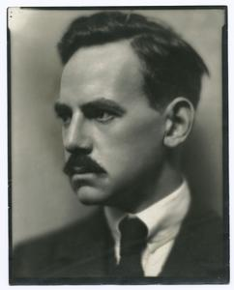
Eugene O’Neill
[Available at: NYPL Digital Gallery: http://digitalgallery.nypl.org/nypldigital/id?100017]

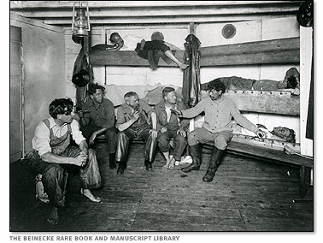
Bound East for Cardiff, Provincetown Players, 1916.
[Available at: http://www.pbs.org/wgbh/amex/oneill/gallery/g_01.html ]

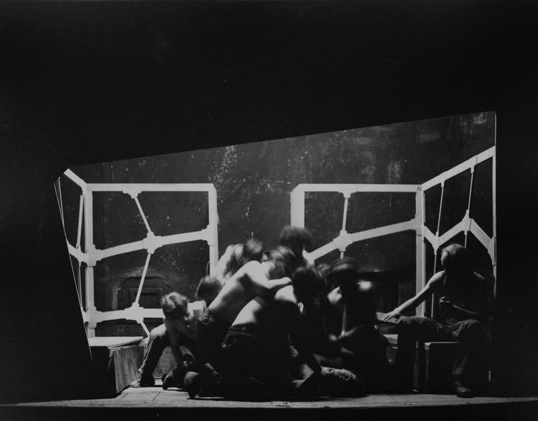

The Hairy Ape, 1922, designed by Robert Edmond Jones and Cleon Throckmorton.
[Billy Rose Theatre Collection, New York Public Library, available at NYPL Digital Gallery, Image ID: 1101521: http://digitalgallery.nypl.org/nypldigital/id?1101521]

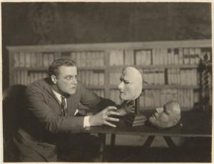

William Harrigan in The Great God Brown, 1926, directed by Robert Edmond Jones.
[Billy Rose Theatre Collection, New York Public Library, available at: http://digitalgallery.nypl.org/nypldigital/id?ps_the_2604]

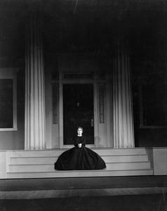
Alice Brady as Lavinia Mannon in the Theatre Guild’s production of Mourning Becomes Electra, 1931, directed by Philip Moeller, designed by Robert Edmond Jones.
[Billy Rose Theatre collection, New York Public Library, available at: http://digitalgallery.nypl.org/nypldigital/id?1110258]

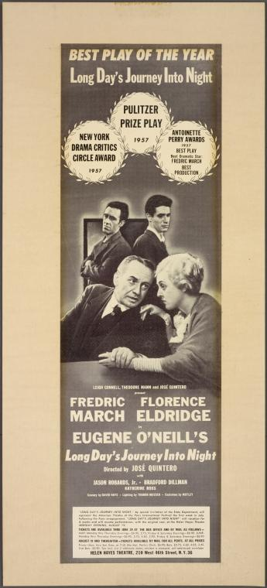

An advertisement for the Broadway premiere of Long Day's Journey Into Night, 1956, directed by José Quintero.
[Billy Rose Theatre Collection, NYPL Digital Gallery, available at: http://digitalgallery.nypl.org/nypldigital/id?1616454 ]

